Independent Age
Telephone Volunteer Training Pack

2018

Welcome

Hi,

A warm welcome to volunteering with Independent Age!
You’re joining an amazing network of volunteers providing older people with much needed friendship and social contact across the UK.
We’ve developed this pack to give you some helpful material to read in advance of your Telephone Volunteer Training. Please work through the exercises in the ‘Before Your Training’ section and jot down your thoughts - it should take around an hour to complete at most.
We’ve also included some information to refer to during your training session and additional guidance, information and resources to refer to if needed later on in your time as a volunteer.
You may want to print this pack to use during the call or if you prefer we can post it to you. Either way it’ll be useful to have your answers to the exercises to hand and a pen and paper ready to note down your responses to the activities we’ll be covering!
At the back you’ll find a handy list of useful telephone numbers, and any we refer to during your training will be noted there.
Thank you for choosing to give your time to Independent Age and to the older people we support – we really couldn’t provide our Friendship Services without you.

We’re looking forward to you joining the team,

Ahra, Russell, Hanifa & Siobhan
The Telephone Services Team

Page |  | Contents
1 |  | Welcome
3 |  | About Independent Age
Before your training
5 |  | The role of a Telephone Volunteer
6 |  | Questioning skills
7 |  | Understanding empathy
8 |  | Maintaining boundaries
9 |  | Safeguarding
10 |  | Quick Quiz
During your training
11 |  | Agenda
12 |  | Older People - Stereotypes
13 |  | Your Role
14 |  | Volunteering Journey
14 |  | Your First Call
15 |  | Questioning, Listening & Positive Language
18 |  | Longer Term
After your training
21 |  | Withholding your number
22 |  | Useful Contact Numbers

About Independent Age

Why we’re here

We want to make the UK a better place to grow old for everyone. What we do is very simple and effective. We understand the issues faced in later life, we campaign for change, and we provide support people can rely on – from clear and simple information guides to a network of volunteers, like you, helping us to beat loneliness and isolation across the UK.

What we offer

You may have heard the phrase “We’re independent, so you can be.” This is because our information and advice is completely impartial - we don’t sell or recommend products - and our campaigning is fiercely independent and based on the needs of older people.
We offer friendship services including Telephone Volunteers, Volunteer Visitors and Telephone Discussion Group Volunteers to reduce isolation, increase self-confidence and independence and improve quality of life.

Did you know?

We have an award-winning range of leaflets that can be ordered from our Helpline or website, and most can be downloaded directly from the website. They cover a range of topics from bereavement, to loneliness, issues around care, home safety, security and many other topics.

Visit our website at https://www.independentage.org/information/advice-guides-factsheets-leaflets or call the Helpline on 0800 319 6789 for further details.

Where we’ve come from
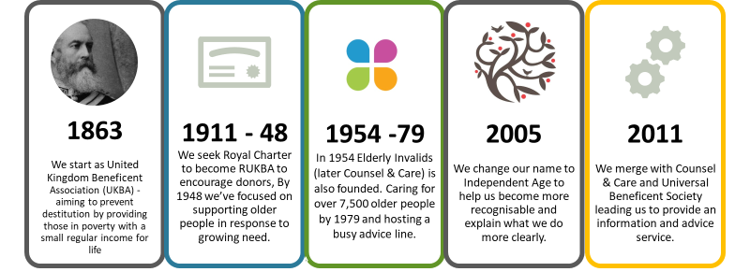

Our achievements in 2017

You’ve hopefully now got an idea of where we’ve been and what we offer. With the support of our dedicated team of volunteers we delivered a huge amount in 2017. Here’s a summary of just a few of the highlights:
We handled 40,360 Helpline enquiries
Over 1,000,000 people accessed our support
We distributed 2,700,000 information guides and resources

About Telephone Services

We’re a small, busy but friendly team of four who work in our London Offices and are just a phone call away on 0207 605 4265 if needed!
Before your training

Please complete the exercises below before you take part in your Telephone Volunteer Training (this will be a telephone conference call).
The answers and further reading can be found under ‘Exercise Answers’, but please try to work through these without reading on if possible!

1: The role of a Telephone Volunteer

Take a look at the list below. Which qualities do you think make an effective Telephone Volunteer? Rate them as either E (essential) D (desirable) or U (unnecessary) and note any other qualities you think are important in the blank space.

Quality | E, D or U?
Non-judgemental
Lots of stories to tell
Respects confidentiality
Acts as a counsellor
Good sense of humour
Knowledge of welfare benefits for older people
A desire to fix people’s problems for them
Good timekeeping
Patience
Has a good rapport with people
Understands the issues older people face
Excellent medical knowledge
A good listener
Other skills & qualities:

2: Questioning skills

As you may know, there are three core types of question commonly used in conversation:

- Open – start with Who, What, When, Why, Where or How and encourage people to share more detailed information
- Closed – where the response is generally a yes or no – useful if you’re trying to conclude a conversation or change topic.
- Probing – helps you to build on an earlier question.

We are going to focus on open questions as these are particularly helpful when you’re making conversation with someone.

Please look at the closed questions below and turn each one into an open question. We’ve done the first one for you…

Have you had a good day?
How’s your day been?’ or ‘How are you?’
Do you watch Strictly?
Are things ok at home?
You seem very happy today, is there a particular reason for that?
You missed our call last week, were you out?
Do you think our phone calls are going ok?

3: Understanding empathy

Empathy is putting yourself in someone else's shoes - an ability to understand what another person is feeling, without having been through the experience yourself. This skill can help us understand another person’s situation more effectively.

Review the statements below and tick the response you think shows you’re trying to see the issue from the other person’s point of view.

“I’ve got something I want to say but I don’t know how to”
Would it help if I call you later?
You want to talk but it is difficult to get started
Well if I don’t know what it is, I’m afraid I can’t help you
Is it to do with what happened earlier?
“Every time I try to get to sleep I can’t because I’m scared of getting nightmares”
You could try sleeping with the light on
You’re worried every night because you don’t want nightmares
If you don’t sleep your health will start to suffer
Perhaps you should go to the doctor
"For weeks the doctor’s been telling me everything’s OK - now he says I might be really ill. I’ve got more tests tomorrow. Who knows what he’ll say”
It won’t help to get upset. These days they can cure most things
He doesn’t sound up to it - no wonder you’re upset. How about talking to the specialist consultant, she’s very good and was very helpful to me
It must be very difficult not knowing how serious your health issues are.
I’ve been through the exact same thing. What can I do to help?

4: Maintaining boundaries

Please look at the scenarios below. Take some time to reflect on them and think about what your reply could be.

Don’t worry, these situations are deliberately difficult and there is no one correct answer.

We’ll discuss similar scenarios during the training - the idea is to explore how to approach unexpected situations over the phone.

- The older person tells you something personal which is similar to something you have experienced. What would you do?

- From what they tell you the older person is becoming increasingly frail and may need medical or home assistance. What would you do?

- You’ve been talking to the older person for some time and discover you live in the same area. They ask if you could meet for a coffee. What would you do?

- The older person makes a passing remark that you think is discriminatory. How would you respond?

5: Safeguarding

The safeguarding training you’ll take part in is very comprehensive and it’s understandable to be concerned about what to do if you think an older person is at risk of abuse.

For a Telephone Volunteer, the only way you’ll be alerted that something may be wrong is if the older person tells you.

Please remember, all you need to do is let us know if you have noticed something odd or are concerned. You can give Telephone Services a call and talk it through if you’re not sure what to do. You can also use our Out of Hours Safeguarding number on 020 7605 4255. if the Independent Age office is closed.

Please read through the scenarios below, which may be potential safeguarding concerns, note down thoughts on what you could do.

Remember, these situations are rare but it’s important to discuss them just in case you ever find yourself in them.

- The older person sounds distressed when you call, saying she doesn’t want her son to come to her home. He’s really upset her and when he comes she always ends up giving him money.

- After losing his wife of 50 years, the older person tells you that he’s considered taking his own life.

- Your call is scheduled at 6pm on a Tuesday evening and the older person doesn’t answer.

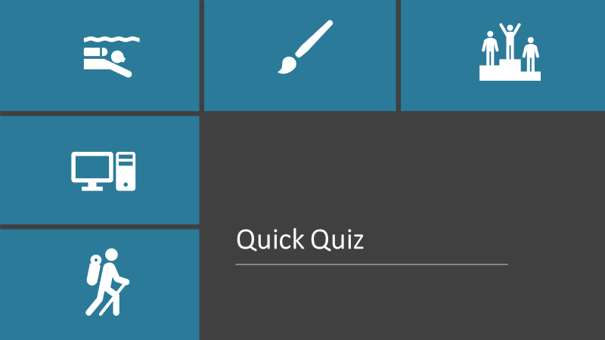

Our training will include a discussion around stereotypes. Please have a read of some of the achievements below to help challenge some stereotypes of older people. Take a guess how old the individuals are (their actual ages can be found at the bottom of the back page).

A | Swiss natives and Vancouver residents Esther and Martin Kafer climbed Mount Kilimanjaro, Africa's highest mountain - some 5,895 metres - setting the new world record for the Oldest couple to climb Mt. Kilimanjaro. How old do you think they were when they did this?
B | Ray Woolley, from Merseyside, spent his birthday diving 38 metres underwater on the wreck of the Zenobia, a Swedish-built cargo ferry that sunk on its maiden voyage in 1980 off the coast of Larnaca in Cyprus, setting a new world record for the Oldest scuba diver. How old was he?
C | Gymnast, Johanna Quaas, performed an impressive parallel bar and floor demonstration after finals concluded at Germany's Cottbus Challenger Cup - setting the new world record for the Oldest Gymnast. How old was she?
D | How old was the oldest female acrobatic salsa dancer Sarah Paddy Jones when she won first prize on a Spanish TV talent show in December 2009?
E | How old was the oldest wing walker Thomas Lackey when he completed a wing walk in Northern Ireland, UK, on 29 August 2013?
F | How old was Shirley Curry when she was crowned world’s oldest videogames youtuber? She has shot hundreds of videos for her channel, building up an impressive fanbase of c240k subscribers and accumulating 6,509,749 views?
G | How old was Ken Bald, the oldest artist to illustrate a comic book cover, when he illustrated the cover of Marvel’s Contest of Champions (2015)

Information taken from www.worldrecordacademy.com

During Your Training

Our conference call will last about 1hr 15 mins to a 1hr 30 mins. The conference call operator will phone you and log you in so all you need to do is be ready for the arranged start time. Full details of this will be sent to you beforehand.

If you get cut off for any reason, please just dial 0800 254 0230
and ask the operator to put you through to Independent Age call
giving the host’s name. We’ll remind you the start of the training.

This section contains some of the key topics and exercises we’ll be discussing with slides to support the conversation – your trainer will let you know when to refer to the pack and explain what you need to do.

As mentioned earlier, please don’t feel you need to print this pack out but do have a pen and paper to hand so you can note down your thoughts during the session.

Agenda

Our training will cover:

- Welcome & Introductions

- About Telephone Services

- Your role

- Volunteering journey

- Questions & Answers

- Support & Next steps

Older People - Stereotypes

‘Older people’ is a phrase that we use a lot. Simply put, older people are just you or I later in life. We aren’t the same now and we won’t be in the future. Our lives will be a result of all the decisions, challenges, life experience, gains and losses in the years ahead.

What are common stereotypes?

How might these stereotypes affect how you interact
with older people?

The British Medical Association in their report “The Perception of Ageing and Age Discrimination” (2016) argue that:

“There is clear evidence that age stereotypes, whether one’s own attitudes to ageing or through discrimination from others, can: a) negatively impact on the ageing processes by influencing health and wellbeing, and b) influence decision making processes and performance on cognitive or physical tasks.

Quoted in the same report - the Ohio Longitudinal Study of Aging and Retirement which followed 660 adults aged 50 years and over for a 23-year period, revealed that individuals who held more positive perceptions of ageing lived 7.5 years longer on average compared to those who endorsed more negative perceptions – so a positive view of older people makes a very real difference!

Your Role

Volunteer Journey

The rest of the training session is now structured around your volunteering ‘journey’ with the organisation, picking up on scenarios or information when it’s likely to come up.

The journey is outlined below - with Telephone Services supporting you throughout whenever needed:

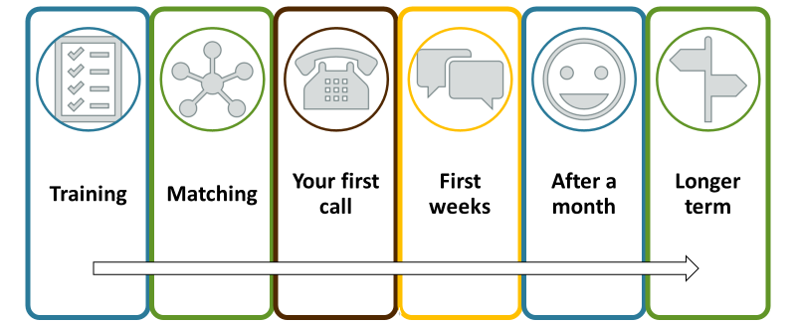

Your First Call

Building rapport with someone involves the three elements to the left.

How do you ….

Give full attention?

Create a positive experience?

Compensate for a lack of non-verbal communication?

Questioning

Open | Closed | Probing
Begin with Who, What, When, Where, Why or How | Questions that can only be answered with yes / no | Questions building on earlier ones
Useful to find out more information | Useful to clarify points or to close off a conversation | Good to show active listening and gain depth in the conversation
E.g. What do you enjoy doing at weekends? | E.g. Are you from London? | E.g. What do you like most about gardening

Use the space below to note down useful open questions to ask to create conversation:

3 Level Questioning
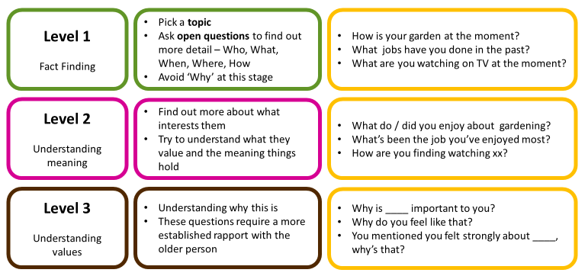

Active Listening

What does active listening sound like? | What are the barriers to active listening?

Techniques to demonstrate Active Listening
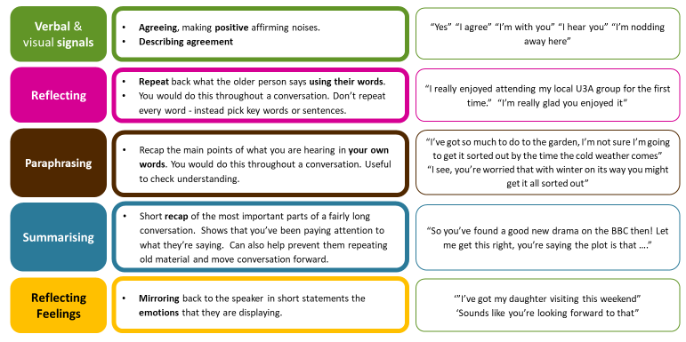

Positive Language

Why not?
No problem

Can’t complain

Weather’s horrid today

I’m exhausted

Don’t worry about…

I couldn’t believe…

Longer Term

Case Study

- You have been calling Mavis for a year. One day she tells you about Brian, a nice man who has moved in nearby. He’s offered to help her out with little errands. Mavis is thrilled as she can do with some help.

- A couple of months go by and Mavis continues to talk about Brian in glowing terms. He now has the keys to her flat and pops his head round most days to see if there is anything she needs.

- After six months Mavis mentions that Brian is popping in a little too much; he no longer knocks before coming in and she feels she has lost control of his visits. Also Mavis says that he doesn’t always give her the correct change. She asked him about this and he appeared annoyed and retorted to say that he keeps a little to cover his time for doing the chore.

- You ask Mavis if she would like some support in explaining how she feels to Brian. She says NO very firmly. She really appreciates his help and doesn’t want anything done that could affect their relationship.

What would you do?

Other ways to get involved

 | Training Volunteer |  | Co-ordinating Volunteer
 | Assessing Volunteers |  | Local Ambassador
 | Volunteer Visitor |  | Fundraiser
 | Information & Advice Volunteer (London Only) |  | Volunteer Administrator (London Only)
 | Follow & support us on social media

Post Training Information

Withholding your number

We will discuss the reasons we ask you to withhold your number during your training session but in summary it’s to keep the boundaries of your relationship clear with the person you call.

From a landline:

- To hide your phone number when making a call, enter the numbers 141 before the phone number. Don't remove any of the digits of the number you're calling.
- Entering 141 is not a permanent way to hide your number. You'll need to enter 141 each time you want to conceal your number.

From a mobile:

- You can also enter 141 before each call that you make. Alternatively, you can change your phone's settings which will allow you to keep your number hidden every time you make a call. The process is different for smart phones and non-smart phones and varies by model.

- For most smart phones; click on "Menu" and then select "Settings" or “General” or "Options." Look for phone settings usually detailed as “Phone” and then “Caller ID” or something similar. Set the option to "Hide" or "Always" depending on what's appropriate and hit "Save."

- For most non-smart phones; click "Menu" and then choose "Settings." Then find and select "Send my caller id" and change the setting to "No." Save your change if necessary.

Useful Contact Numbers

Telephone Services Team

Please call us if you need any support in your volunteering role.
T. 0207 605 4265 E: telephone.volunteers@independentage.org

Volunteering Team

Please call us for general volunteering enquiries, Get Togethers communications and training.
T. 0207 605 4255 E: volunteering@independentage.org

Independent Age Helpline

Free impartial advice about finances, health, care and home for older people.
T: 0800 319 6789 (Mon - Fri, 8.30am to 6.30pm and Sat, 9am to 1pm)
E: advice@independentage.org

Safeguarding Out of Hours

If you have a safeguarding concern about an older person you support as a volunteer, call Telephone Services during office hours (Mon-Fri – 9am to 5pm).

If you have an urgent safeguarding concern out of office hours, please call 020 7605 4455 on weekdays 8am - 9am in the morning and 5pm - 9pm. On weekends cover applies from 8am - 9pm on Sat & Sun and during periods such as Christmas.

Samaritans

Free helpline ‘Talk to us any time you like, in your own way, and off the record – about whatever’s getting to you. You don’t have to be suicidal’.
T: 116 123 E: http://www.samaritans.org/

Online resources

You can order advice guides and access information and videos on our website: https://www.independentage.org/
For stories from the older people we support, volunteers and advice tips, you can check our youtube channel: https://www.youtube.com/user/IndependentAge

Training feedback

We’d like to hear your feedback about our training, if you could spare 5 minutes, please complete a quick form on this link: https://www.surveymonkey.co.uk/r/TelVolTraining

Quiz answers | A - 84 & 85 | B - 94 | C - 86 | D - 75 | E - 93 | F - 81 | G - 95

